Spring VLGMA DAO Meeting Details
Host: Gloucester County, Virginia (It’s pronounced Glaw-ster.)
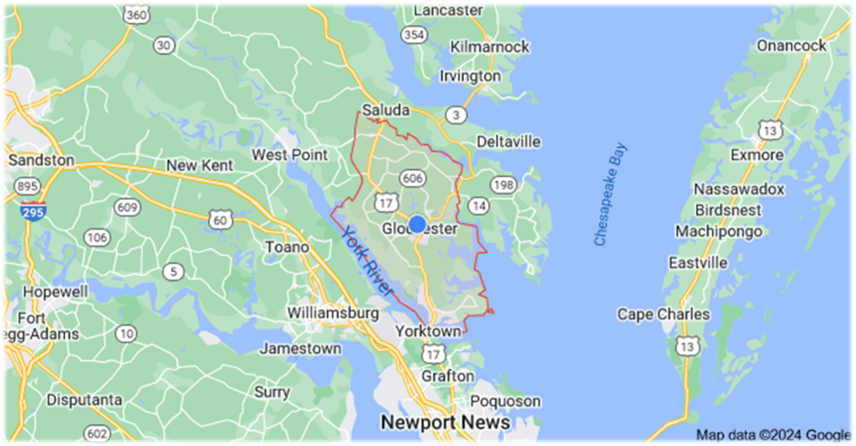
Registration is open for the next VLGMA Deputies, Assistants and Others (DAO) meeting.

Date: Friday, April 19th 8:30am to 4:00pm
Hosts: Gloucester County, Virginia
Location: Fine Arts Museum of Gloucester
- Main Street, Gloucester, VA 23061
Topics will include Lead from the Heart: Transformational Leadership for the 21st Century, DAO Roundtable: Facilitated Discussion Regarding Some of Your Most Pressing Concerns, Enhancing Your Branding in a Cost-Effective Way (Gloucester’s Experience) and Highlighting Gloucester’s Tourism Efforts.
As long as the weather is nice, we plan a brief walking tour of the historic Mainstreet area and will discuss the Public-Private Partnerships of Gloucester County and the Main Street Preservation Trust.

A draft agenda is forthcoming. Information can also be found on the DAO page of the VLGMA website.

Your prompt registration is appreciated if you plan to attend. The deadline to register is Wednesday, April 3rd. Lunch will be provided by Gloucester, so please make sure to respond to Alysse when she reaches out to get your order. We look forward to having an engaging in-person meeting.

Sincerely,

Steve Wright, MPA George Bains
Deputy County Administrator Deputy County Administrator
Gloucester County Gloucester County

DAO Meeting Website - https://www.vlgma.org/dao
Online registration - https://coopercenter.my.site.com/main/s/login/

Date: Friday, April 19, 2024
Times: 8:30 am to 4:00 pm
- Registration and light refreshments will begin at 8:30 am. The program will commence at 9 am.
- A tour of the historic Mainstreet area, weather permitting, will conclude the day. Participants should bring comfortable shoes.
Venue: Fine Arts Museum of Gloucester, 6894 Main Street, Gloucester, VA 23061 https://thecookfoundation.org/ ine-arts-museum-of-gloucester
Proposed Agenda Topics:
- Lead from the Heart: Transformational Leadership for the 21st Century
- DAO Roundtable: Facilitated Discussion Regarding Some of Your Most Pressing Concerns
- Enhancing Your Branding in a Cost-Effective Way (Gloucester’s Experience)
- Highlighting Gloucester’s Tourism Efforts
- Public-Private Partnerships: Gloucester County and Main Street Preservation Trust
Food (AKA-the important stuff):
Light breakfast refreshments and lunch will be provided. Lunch will be provided by Gloucester County. We will, also, have light morning refreshments available (including coffee). Alysse (alysse@virginia.edu) will reach out to you to get your lunch orders before the day of.
You may want to stay after the meeting and visit Gloucester Brewery, Olivia’s, or Lulu Birds Kitchen for fine food and libations.
Lunch Menu
Sweet Tooth Cafe Lunch Boxes (https://sweettoothcafeandbakery.com/)
Each selection is served with your choice of cinnamon apples, chips, cucumber salad, OR pasta salad AND cookie, brownie, or southern banana pudding. Gluten Free Bread and Keto Wrap are also available.
Sandwiches
- Turkey and Cheddar – Our Boars Head oven roasted turkey, Cheddar Cheese, Lettuce, tomato on sourdough.
- Ham and Cheddar – Our Boars Head black forest ham, Cheddar Cheese, Lettuce, and tomato on sourdough.
- BLT – Boars Head smoked bacon, lettuce and tomato on sourdough.
- Chicken Salad – our house chicken salad with grapes, lettuce and tomato on sourdough.
- Tuna Salad – our house tuna salad, lettuce and tomato on sourdough.
- Roast Beef/Gouda – Boars Head London broil Roast Beef, Smoked Gouda, lettuce, tomato on sourdough.
- Turkey Club – Boars Head oven roasted turkey, smoked bacon, lettuce, and tomato on sourdough.
Wraps
- Chicken Caesar Wrap – grilled chicken, Asiago blend cheeses, romaine lettuce served with Caesar dressing on the side.
- Thai Chicken Wrap – grilled chicken, Portobello mushrooms, carrots, onions, cashews, mandarin oranges, and mixed greens. Thai dressing on the side
- Chicken Supreme Wrap – our house chicken salad, mandarin oranges, cranberries, almond slices and mixed greens.
- Greek Wrap – mixed greens, carrots, tomatoes, cucumbers, red onions, banana peppers, Kalamata olives, feta cheese. Balsamic dressing on side.
- Veggie Wrap – mixed greens, carrots, tomatoes, cucumbers, red onions, feta cheese. Balsamic dressing on side.
- Caesar Salad – Asiago cheese blend, house croutons, and romaine. Served with Caesar dressing.
Salad Lunch Boxes
Served with a baguette and your choice of a cookie, brownie, or southern banana pudding. Your choice to add grilled chicken, vegan chicken, or marinated steak.
- Greek Salad –mixed greens, banana peppers, Kalamata olives, tomatoes, cucumbers, carrots, red onion, and feta. Served with balsamic dressing.
- Field Salad – mixed greens, almond slices, feta cheese, cranberries, tomatoes, cucumbers.
- Strawberry Salad – fresh sliced strawberries, walnuts, feta cheese, and romaine. Served with red wine vinaigrette.
- Asian Salad –mixed greens, red onion, carrots, Portobello mushrooms, mandarin oranges, cashews. Served with Asian dressing.

